Quantum Image Watermarking extraction against Geometric Flipping Attacks using NEQR

Abstract
In the domain of Quantum Image Processing (QIP), this paper explores the feasibility of digital watermarking against geometric flipping attacks. There are so many computational advantages of Quantum image processing, but under spatial flipping transformations (Flip X and Flip Y), the behavior of steganography is unexplored. In this paper, we used Novel Enhanced Quantum Representation (NEQR) to embed the Binary watermark into the grayscale Cover image’s LSB (Least Significant Bit). The watermarked Quantum Image will now undergoes through the Geometric Flipping across X and Y Axis and by monitoring the Spatial coordinates that will be resulted as flipped or mirrored. To extract the watermark from the Flipped images we have implemented two Distinct Quantum Circuits. The first method Extracts the watermark directly from the flipped image by coordinate mapping. The second method uses the Quantum State reversion algorithm to inversely restore the image dimensions first and then we use standard extraction method to extract the watermark. The simulation results verified that mathematical accuracy of proposed circuits achieving 100 % extraction from the geometrically attacked images.
Keywords: Quantum Image Processing, NEQR, LSB Steganography, Geometric Flipping Attacks, Flip X, Flip Y, Quantum State Reversion.

Introduction
Quantum Computing: By Combining Quantum Mechanics with Computer science the traditional Computing paradigms have changed Completely[2]. In Classical Computers we use Binary bits (0 and 1) and sequential processing. But in Quantum systems We use some unique Quantum Properties like Superposition and Entanglement to process the data[4].Because of these Quantum Characteristics a system once can Evaluate Huge information spaces. Because of this some complex Computational Problems get Exponential speedup.
Image Processing: As Modern Classical image processing systems Processes high- resolution image data they face hardware limitations[10]. For storing and Modifying big images matrices they require high cpu processing power and memory. As the multimedia data is increasing day by day, the traditional computing methods were not efficient. So to process Large-scale images in a faster way we require other high computing alternatives.
Water Marking: As we can easily share this Digital media through Internet we get copyright infringement and unauthorized distribution problems. To protect intellectual property, The Steganography and Digital water marking are the Core Techniques. Steganography is the process of embedding the secret information into a normal cover image. This results to giving a subtle change in Cover Image without effecting the quality and with those invisible modifications we can get the copyright protection.
Quantum Image Processing: Quantum Image Processing will provide a solution for the limitations of classical hardware. The Classical pixel information will be represented into quantum states and it uses quantum parallelism for optimization of memory usage and accelerates image processing tasks. In this field, Novel Enhanced Quantum Representation (NEQR) gives the robust mathematical results. it helps in Performing the arithmetic and geometric transformations in Quantum image circuits.
Proposed Work
Implementing LSB steganography inside the NEQR model has proven successful for digital watermarking. However, the robustness of these payloads against geometric alterations like spatial flipping is a critical blind spot. This paper targets the failure of extraction caused by flipping adjustments. We investigate how the embedded watermark behaves after severe Flip-X (vertical flip) and Flip-Y (horizontal flip) transformations. To extract the data, we use two distinct methods: Direct Coordinate Mapping and Quantum State Reversion.

Core Breakthroughs
    - A data hiding framework that embeds secure LSB quantum watermarks directly into NEQR-Encoded Images.
    - Mathematical and circuit-level explanations of how Geometric Flips (X and Y) affect the spatial arrangement of hidden steganographic information.

    - Utilizing Direct Coordinate Mapping to extract the watermark directly from the flipped image.
    - Reversing the geometric flip mathematically to restore the original image shape prior to extraction.

Methodology
Our approach introduces an end-to-end Quantum Steganographic pipeline. To test how well the hidden watermark survives changes in geometric orientation, the system applies simulated spatial flipping gates.


Figure 1: Block diagram of the proposed three-stage framework.

Quantum Embedding Process:
Before any attack can be simulated, the initial state must be prepared. The cover image and binary watermark are entangled into a unified NEQR quantum state. The watermark payload is embedded securely into the Least Significant Bit (LSB) of the grayscale pixel intensity register.
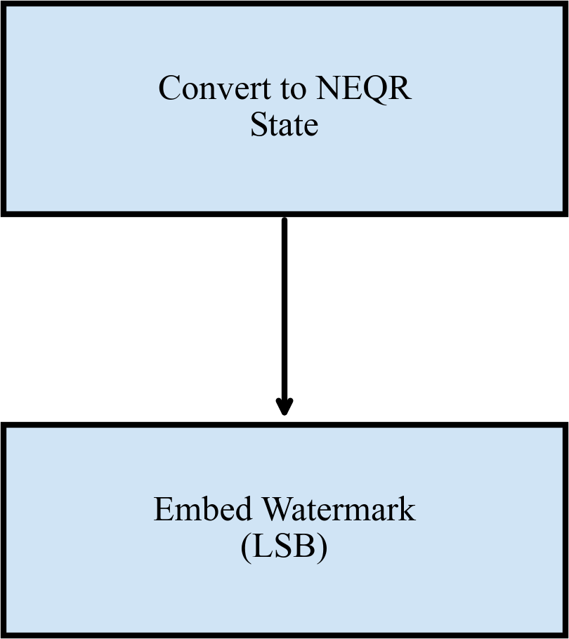

Figure 2: Workflow of the LSB Quantum Steganography embedding process.

Geometric Flipping Attacks: In Step 2, we subject the Stego-Image to spatial flip attacks (Flip X and Flip Y). The two flip attacks are mathematically modeled by applying Pauli-X gates to the spatial coordinate registers:
For Flip X (flipping along the horizontal axis, affecting Y-coordinates):
U_{F} _{lip} _{X} = X^{⊗n}(|Y ⟩)
For Flip Y (flipping along the vertical axis, affecting X-coordinates):
U_{F} _{lip} _{Y} = X^{⊗n}(|X⟩)

Because the spatial registers are mirrored, standard extraction fails.



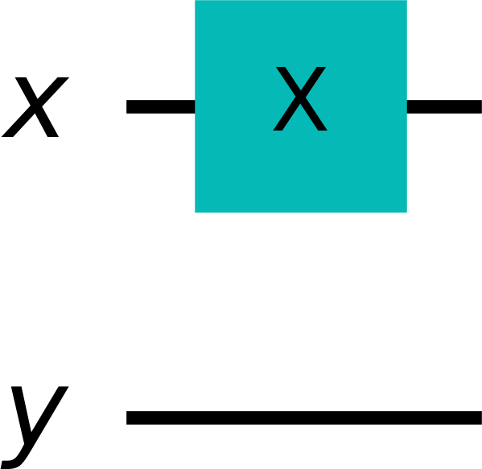

Figure 3: Isolated Quantum Operational Circuits for Flip X and Flip Y Attacks.

Approach 1: Direct Extraction via Coordinate Mapping:
The first approach uses classical post-selection re-wiring to isolate the correct coordinate matrix. By mapping the classical registers inversely (e.g., Y → 1 −Y for Flip X), the original watermark is reconstructed flawlessly.



Figure 4: Direct Coordinate Mapping Extraction approach for Flips.

Approach 2: State Reversion Extraction:
The second approach is a structural reversible mechanism. In this method, the mathematically exact inverse quantum flip gates are applied to the Stego-image. Since a geometric flip is its own inverse, applying a second Flip gate perfectly restores the spatial dimensions of the image.

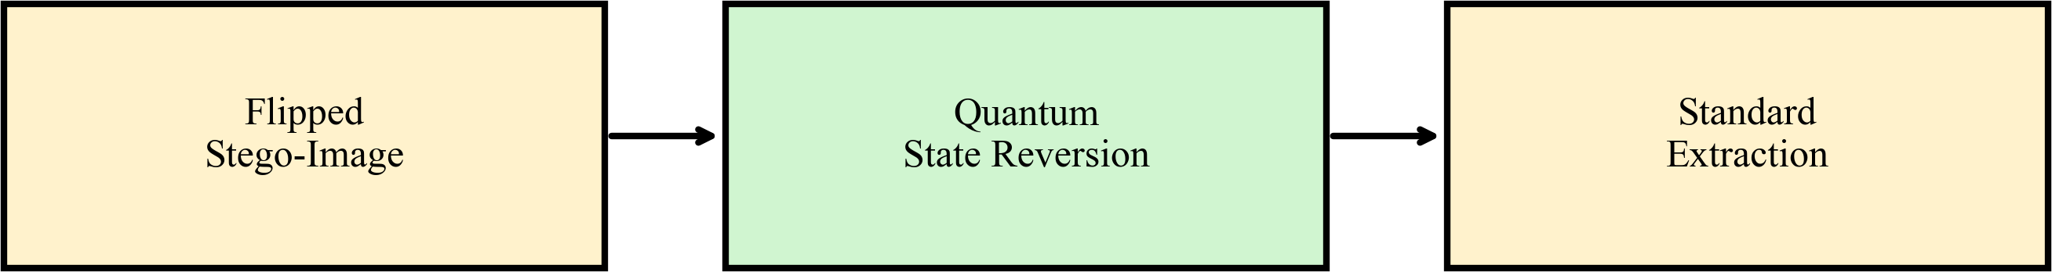

Figure 5: The Quantum State Reversion extraction approach for Flips.

Results and Discussions
To validate the framework, a 2 × 2 grayscale image was selected as the cover image and a 2 × 2 binary watermark was embedded. The performance was evaluated after simulated Flip X and Flip Y attacks.

Original Images:
Cover Image:

Watermark Image:

C = 1 2
7 4

W = 1 0

1 1

Quantum Flipping Attack:
After applying a Flip X attack, the cover image becomes:

C′ = 7 4
1 2
And after applying a Flip Y attack, the cover image becomes:

C′ = 2 1
4 7
The quantum circuits successfully simulate these inversions.

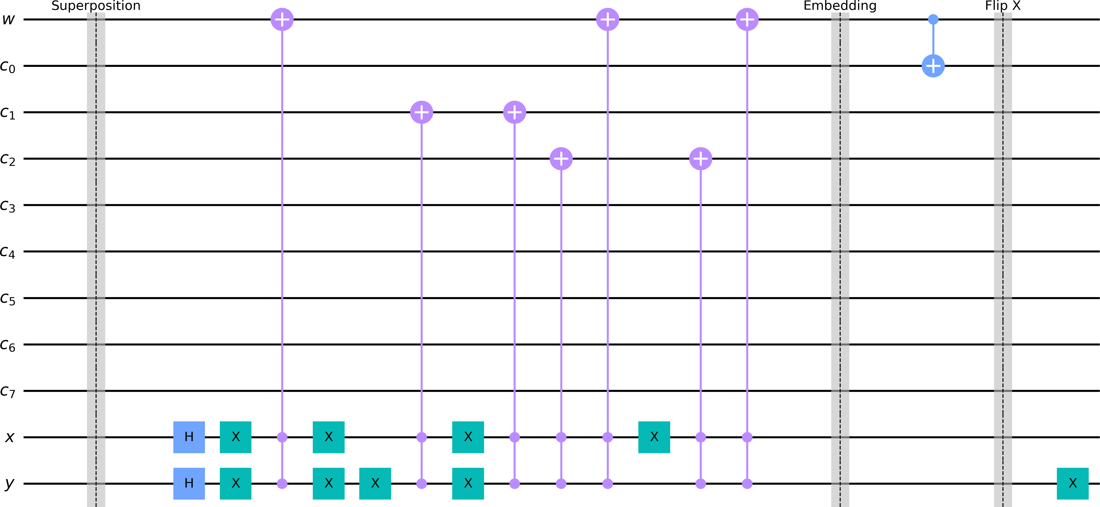
Figure 6: Full Stego Circuit for Flip X.

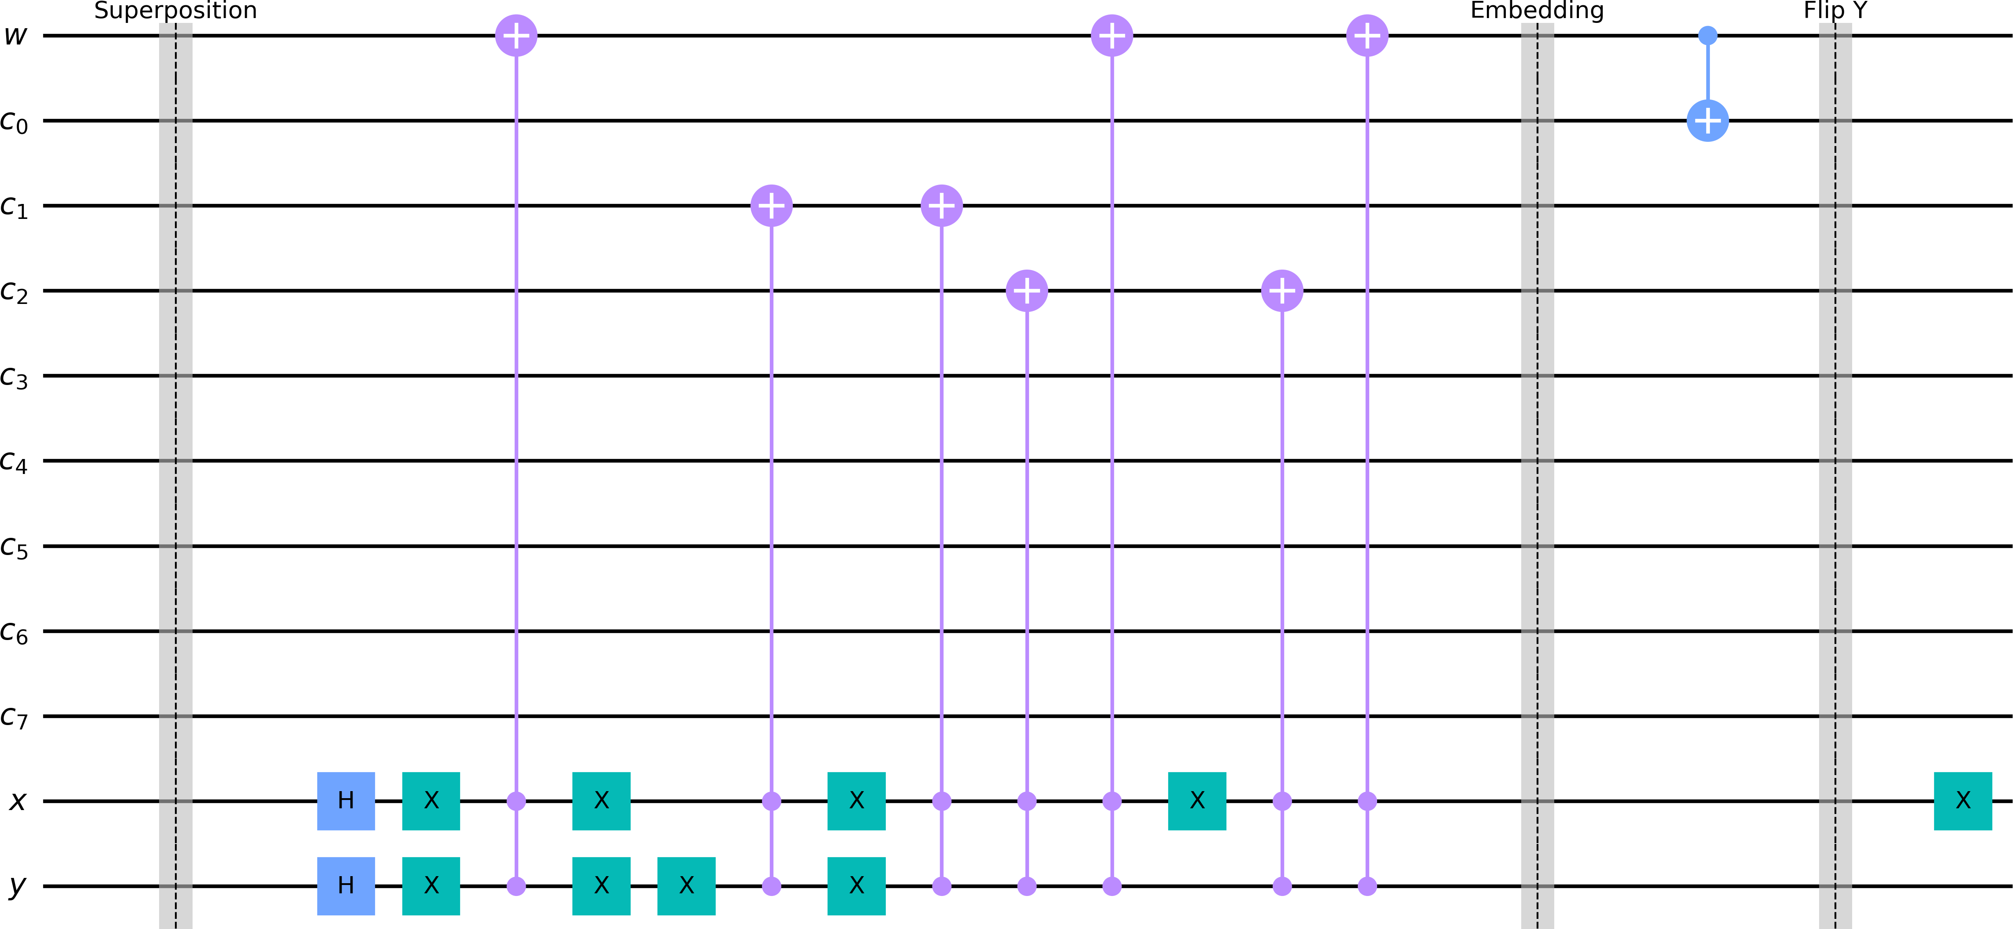
Figure 7: Full Stego Circuit for Flip Y.

Both extraction methods were verified using IBM Qiskit qasm simulator over 100,000 shots, consistently extracting the watermark with 100% fidelity.

Extraction using Approach 1:
The Direct Coordinate Mapping circuit extracts the data by inversely mapping the flipped classical bits during measurement. This retrieves the original watermark directly from the attacked state without altering the quantum image. The extracted watermark matrix matches the original payload exactly:
Wextracted = 1 0 This confirms 100% extraction fidelity for Approach 1.
1 1

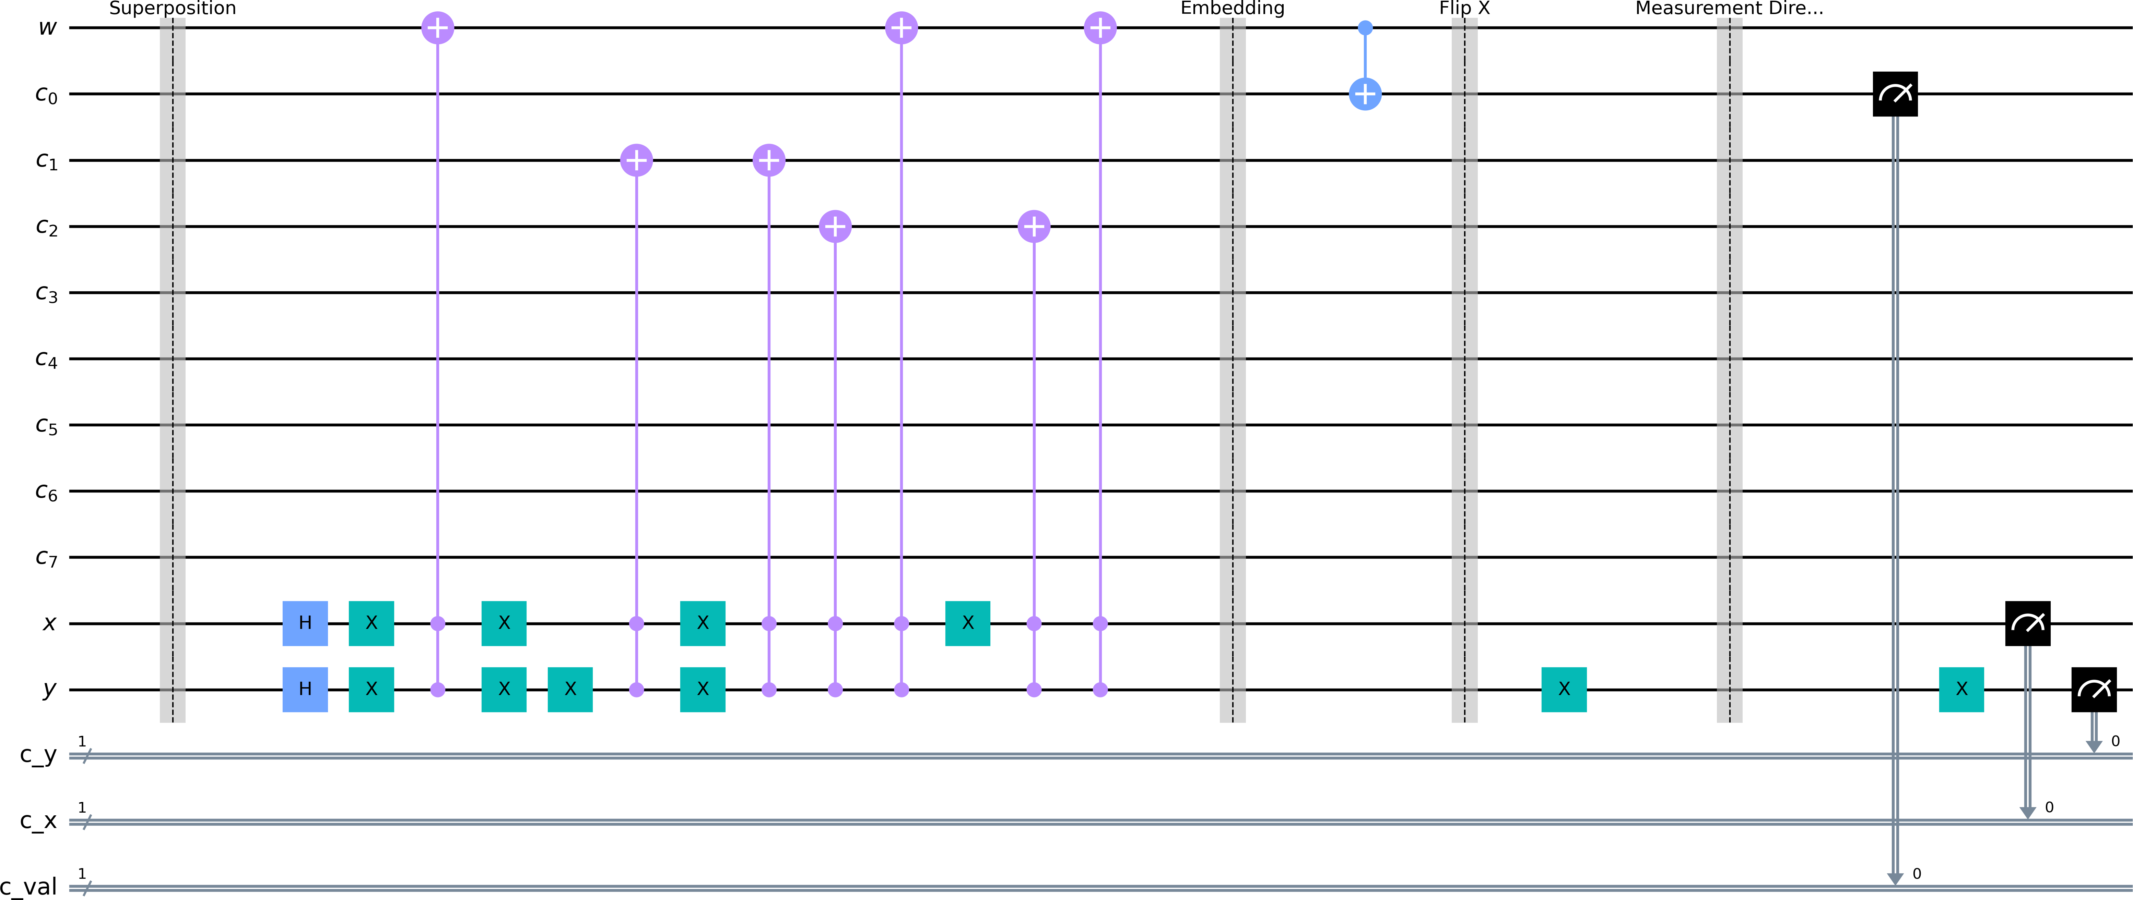

Figure 8: Direct extraction quantum circuit for Flip X

Extraction using Approach 2:
For the State Reversion approach, an identical Flip X operation is applied to the stego-image prior to extraction. Because a geometric flip is its own mathematical inverse, the spatial layout structurally collapses back into the original unattacked 2 × 2 grid. The standard extraction protocol then flawlessly retrieves the watermark:
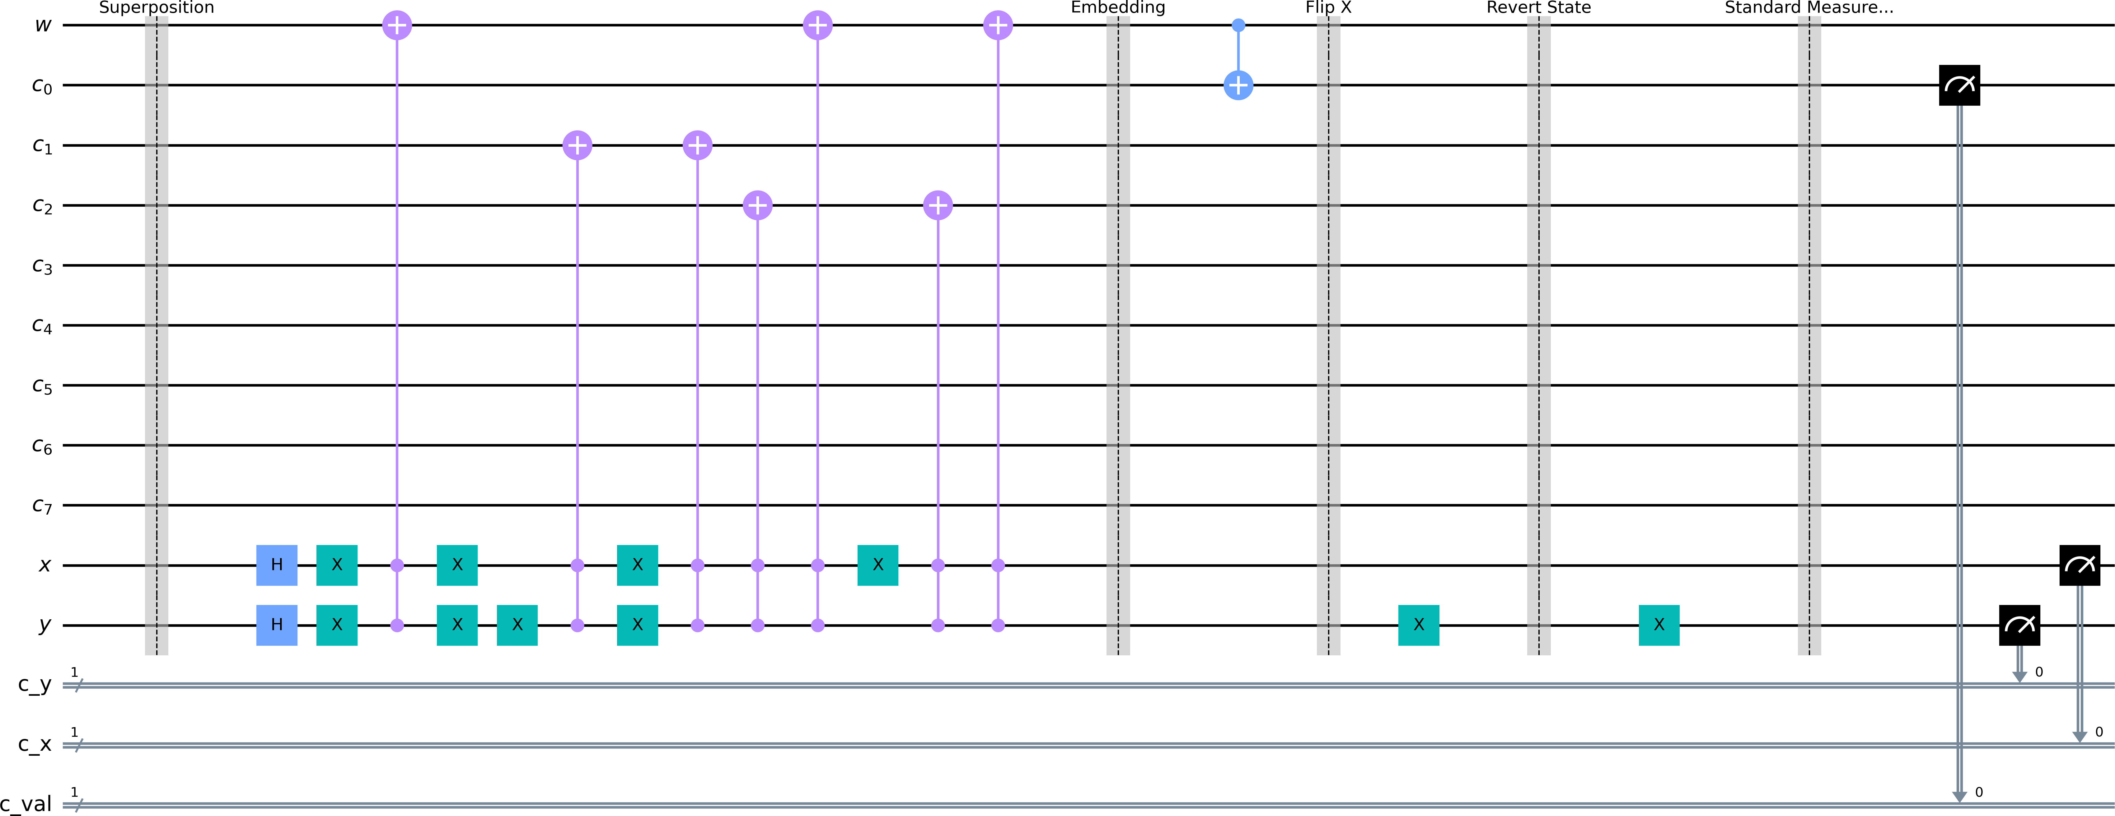
Wextracted = 1 0 This confirms 100% extraction fidelity Approach 2.
1 1

Figure 9: Reversion extraction quantum circuit for Flip X

Conclusions and Future Extensions

Conclusion:
In this paper, we proposed a framework using NEQR for Geometrically flipped images. We achieve 100% extraction fidelity from the flipped image while preserving the visual quality of the original cover image, by using two extraction methods (Direct Extraction and State Reversion)
In future work, we will evaluate this pipeline against fully blind quantum extractions, utilizing quantum image moments or geometric center-of-mass detection circuits to natively identify and revert the flipping dimension entirely within the quantum register prior to measurement.

References
- M. A. Nielsen and I. L. Chuang, Quantum Computation and Quantum Information, 10th Anniversary ed. Cambridge, U.K.: Cambridge University Press, 2010.
- P. Kaye, R. Laflamme, and M. Mosca, An Introduction to Quantum Computing. Oxford, U.K.: Oxford University Press, 2007.
- A. Pathak, Elements of Quantum Computation and Quantum Communication. Boca Ra-ton, FL, USA: CRC Press, 2013.
- N. S. Yanofsky and M. A. Mannucci, Quantum Computing for Computer Scientists. Cam-bridge, U.K.: Cambridge University Press, 2008.
- C. Bernhardt, Quantum Computing for Everyone. Cambridge, MA, USA: MIT Press, 2019.
- S. E. Venegas-Andraca, Quantum Walks for Computer Scientists. San Rafael, CA, USA: Morgan & Claypool Publishers, 2008.
- F. Yan and S. E. Venegas-Andraca, Quantum Image Processing. Singapore: Springer Na-ture Singapore Pte Ltd., 2020.
- A. I. Mihovska and S. E. Venegas-Andraca, Quantum Image Processing in Practice. Hobo-ken, NJ, USA: John Wiley & Sons, 2024.
- R. C. Gonzalez and R. E. Woods, Digital Image Processing, 3rd ed. Upper Saddle River, NJ, USA: Pearson Prentice Hall, 2008.
- M. Sonka, V. Hlavac, and R. Boyle, Digital Image Processing and Computer Vision. Clifton Park, NY, USA: Cengage Learning, 2008.
- D. A. Forsyth and J. Ponce, Computer Vision: A Modern Approach. Upper Saddle River, NJ, USA: Prentice Hall, 2003.
- A. M. Tekalp, Digital Video Processing. Upper Saddle River, NJ, USA: Prentice Hall, 1995.
- I. J. Cox, M. L. Miller, J. A. Bloom, J. Fridrich, and T. Kalker, Digital Watermarking and Steganography, 2nd ed. Burlington, MA, USA: Morgan Kaufmann Publishers, 2008.

